- DNS, HTTP/HTTPS AND WIRESHARK ASSIGNMENT

Q1. Capture Spotify Traffic and Identify DNS and HTTPS Packets
Objective: Capture traffic while opening Spotify's website and identify at least two DNS packets and two HTTP/HTTPS-related packets.
Steps:
- Open Wireshark and double-click your active Wi-Fi or Ethernet interface to start capturing.
- Open a browser. To generate fresh traffic, open www.spotify.com or refresh it while Wireshark is capturing.
- Capture for around 30-60 seconds, then return to Wireshark and click the red Stop button.
- In the display filter bar, type dns and press Enter. Look in the Info column for entries such as Standard query and Standard query response.
- Select two DNS packets from your own capture and write their packet numbers and short descriptions below.
- To inspect secure web traffic, try tls or tcp.port == 443. Modern browsers can also use HTTP/3 over QUIC, so quic may appear. Select two suitable packets from your capture.
dns
tls
tcp.port == 443
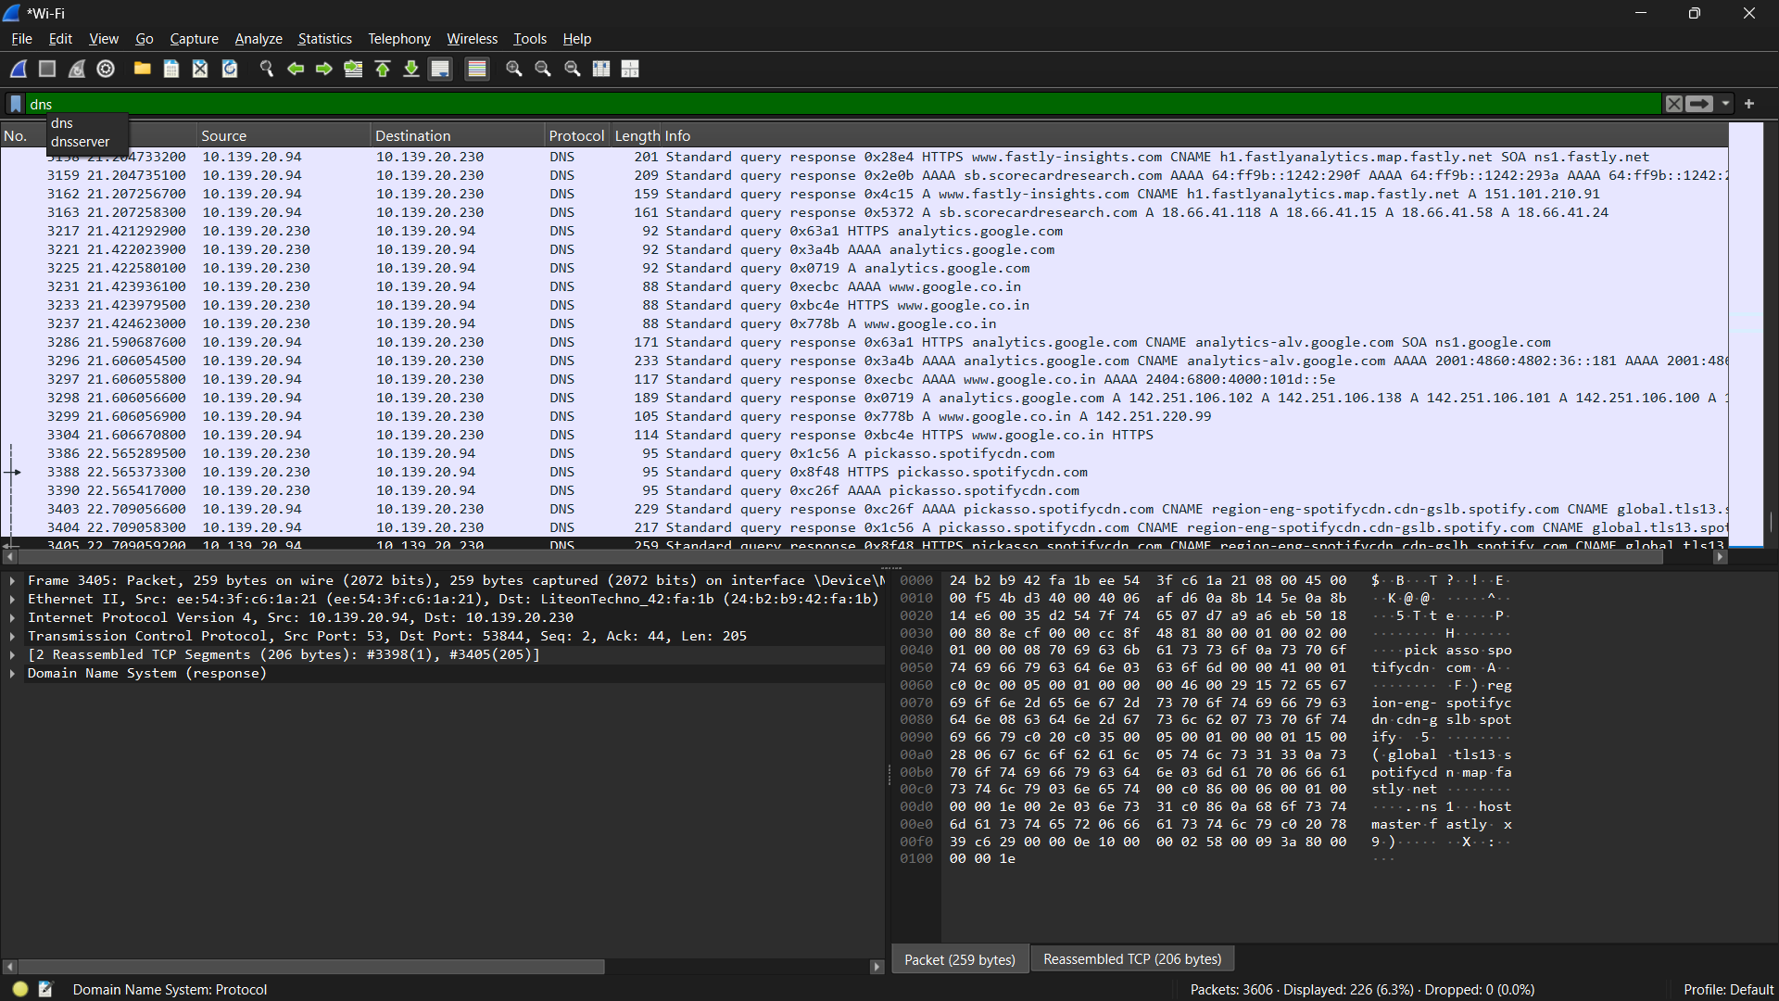
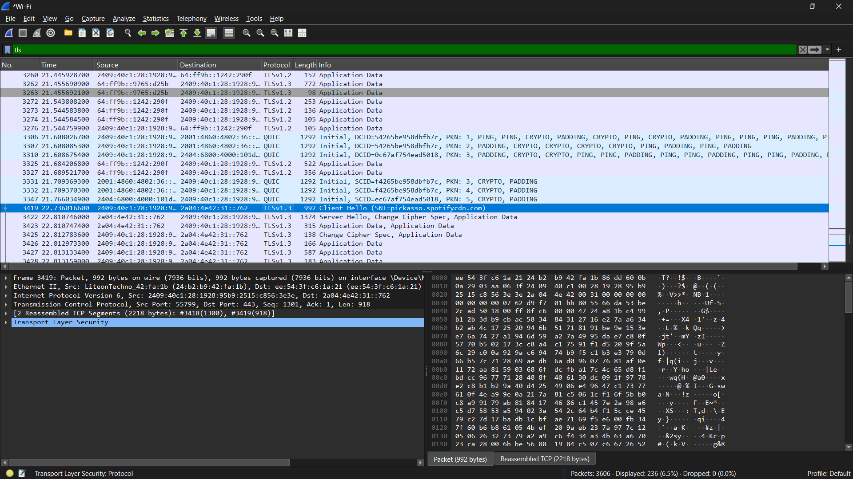
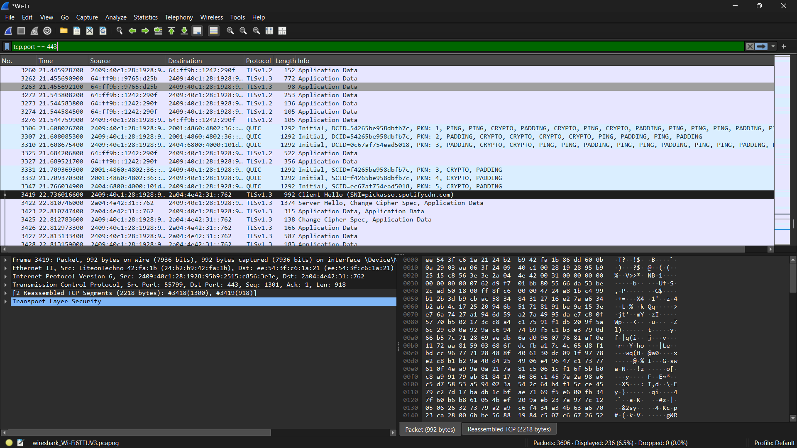
Q2. DNS Lookup for www.flipkart.com Using nslookup
Steps:
- Press Windows + R, type cmd, and press Enter.
- Type nslookup www.flipkart.com and press Enter.
- Look for the Address or Addresses returned for www.flipkart.com. Depending on your network and DNS response, one or more IPv4/IPv6 addresses may be shown.
- Write the IP address(es) exactly as displayed on your computer and take a screenshot.
nslookup www.flipkart.com
Explanation: DNS converts the domain name www.flipkart.com into an IP address that a computer can use to locate and communicate with the website's server or content-delivery infrastructure. The exact address can vary by location, time and DNS/CDN routing.
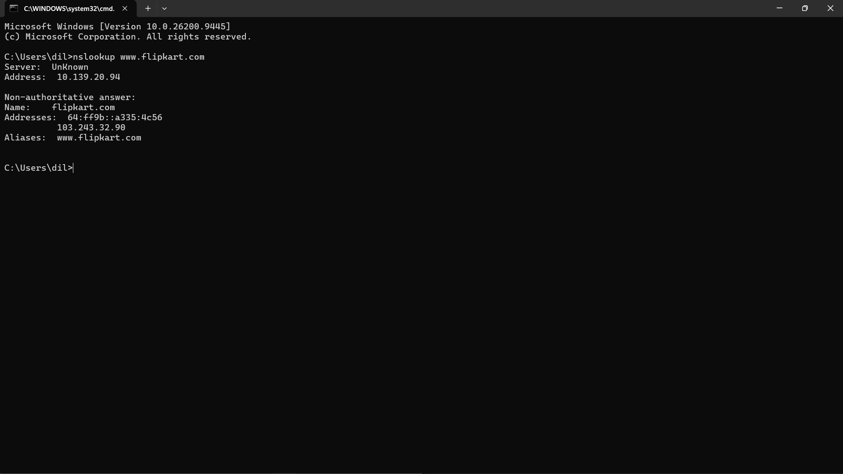
Q3. Difference Between HTTP and HTTPS
Point | HTTP | HTTPS
Security | Data is not protected by TLS encryption. | Uses TLS encryption to protect data in transit.
Default Port | Commonly uses TCP port 80. | Commonly uses TCP port 443; HTTP/3 can use QUIC over UDP 443.
Trust/Use | Not suitable for sending sensitive information over an untrusted network. | Used for secure logins, payments and most modern websites.
Real-world example: Spotify uses HTTPS for secure communication between the browser/app and its web services. HTTPS helps protect information in transit from being easily read or modified by someone observing the network.
No practical screenshot is required for Q3 unless your trainer specifically asks for one.
Q4. Observe DNS Queries and Responses in Wireshark
Steps:
- Start a new Wireshark capture on your active Wi-Fi/Ethernet interface.
- In the display filter bar, enter dns and press Enter.
- Open a website you have not visited recently. Using a fresh/private browser window can help, but DNS caching or encrypted DNS may still affect what appears.
- Watch the Wireshark Info column for Standard query entries and matching Standard query response entries.
- Stop the capture and select a query/response pair. Compare the transaction ID, queried name and returned address information where visible.
- Describe the sequence using the observations from your own capture.
dns
Note: If no normal DNS packets appear, the browser/system may be using cached DNS information or encrypted DNS such as DNS-over-HTTPS. Try a different new domain, clear the relevant DNS cache if permitted by your trainer, or document what you observed rather than inventing packets.

Q5. Real-World Scenario Using DNS
Selected Protocol: DNS (Domain Name System)
Scenario: Suppose I connect my phone or laptop to Wi-Fi and open Spotify. I enter spotify.com instead of remembering a numerical IP address. The device sends a DNS request to find the IP address associated with the domain name. After the DNS response is received, the device can use the returned address to start communicating with Spotify's servers. DNS therefore works like an Internet phone book by translating easy-to-remember domain names into network addresses.
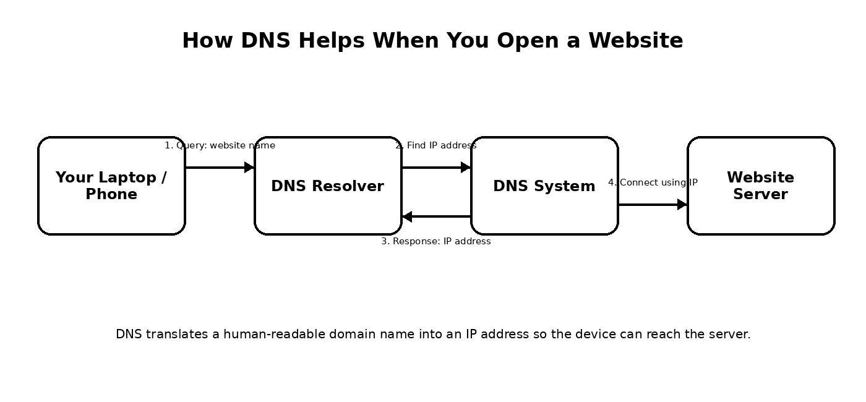
Figure: Simple DNS query and response flow.
Conclusion
This practical assignment demonstrates how DNS resolves website names, how Wireshark can be used to observe DNS and secure web-traffic metadata, and why HTTPS is safer than HTTP for modern Internet communication.

